**10-BIT DIGITAL TO ANALOG CONVERTOR**

**Abstract**

The integrated circuit 10-bit digital-to-Analog converter combined with a high stability voltage reference fabricated on a single monolithic chip. Using precision high speed current-steering switches, a control amplifier, voltage reference, and resistor network, the device produces a fast, accurate Analog output current. output application resistors are also included to facilitate accurate, stable current-to-voltage conversion; they are with required accuracy, thus eliminating external disturbances in many situations. Several important technologies combine to make it the most accurate and most stable 10-bit DAC available. The low temperature coefficient, high stability network is trimmed at the Wafer level by a fine resolution system to typical linearity. This results in an accuracy specification.

**Schematic Diagram**

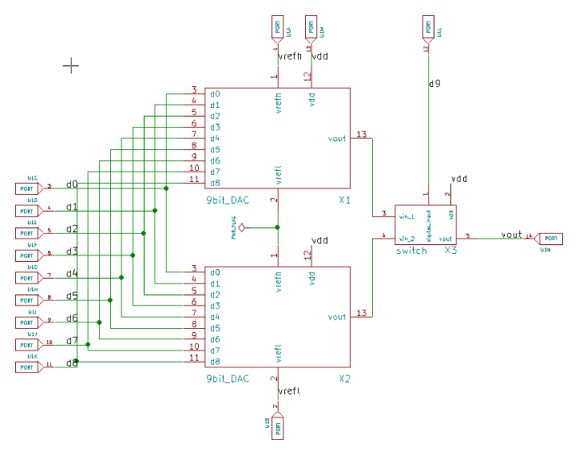

**Application**

* Battery powered test instruments
* Digital offset and gain adjustment
* Battery operated or Remote industrial controls
* Machine and motion control devices
* Cellular telephones

**Reference**

[**A 10-bit 20 MS/s successive approximation register analog-to-digital converter using single-sided DAC switching method for control application**](https://www.researchgate.net/publication/285601743_A_10-bit_20_MSs_successive_approximation_register_analog-to-digital_converter_using_single-sided_DAC_switching_method_for_control_application)

In this paper 10-bit 20MS/s successive approximation register (SAR) analog-to-digital converter (ADC) implemented in TSMC 0.18-um CMOS process is presented control application as a part of the biological signal acquisition system. By applying single-sided switching method that reduces DAC switching energy, the proposed SAR ADC achieves less power consumption

[**An N-bit DAC with adjustable Precision and Range**](https://www.researchgate.net/publication/272072644_An_N-bit_DAC_with_adjustable_Precision_and_Range)

Now some special circuits need higher precision in relatively fixed range. While the precision of a common digital-to-analog converter (DAC) is equidistant, which means the higher the precision is, the greater the number of bits. The increase of number of bits will slow down the speed of converter. This architecture we present here aims at finding a way of solving the problem

[**8-bit folding ADC based on switched capacitor**](https://www.researchgate.net/publication/261204196_8-bit_folding_ADC_based_on_switched_capacitor)

This paper presents an 8-bit folding analog-digital converter (ADC) using switched capacitors. In this architecture, the conversion is achieved when the signal crosses a determined voltage level and at this time, a voltage value is added or subtracted from the analog input signal. The ADC proposed consists of eight identical stages that perform the conversion of one bit at a time